Project Report Format

# INTRODUCTION

* 1. **Project Overview:**

CleanTech is an AI-powered waste classification system that uses transfer learning to automate the identification and categorization of municipal solid waste. The system leverages pre-trained convolutional neural networks to classify images of waste into three categories: Biodegradable, Recyclable, and Trash. This project aims to improve the accuracy and efficiency of waste sorting in various real-world scenarios such as smart bins, recycling centers, and industrial environments

* 1. **Purpose:**

The primary goal of CleanTech is to reduce human error, increase waste processing speed, and encourage better recycling practices by automating the waste classification process using Transfer Learning.

# IDEATION PHASE

* 1. **Problem Statement:**

Waste segregation is a manual, labor-intensive task prone to error, leading to inefficient recycling and increased landfill accumulation. There is a need for an automated system that can reliably classify waste at source

* 1. **Empathy Map Canvas:**

Users: Citizens, waste management workers, municipal corporations

Needs: Accurate, fast, and user-friendly waste classification

Pains: Manual effort, misclassification, low awareness

Gains: Automation, efficiency, sustainability

* 1. **Brainstorming:**

Image-based classification

Integration with smart bins

Use of mobile/web apps for uploading waste images

Future extension to voice commands and QR integration

# REQUIREMENT ANALYSIS

* 1. **Customer Journey map:**

User throws waste in a smart bin or uploads image.

System captures or receives the image.

Image is classified using the AI model.

Classification result is displayed and logged.

* 1. **Solution Requirement:**

Trained deep learning model

Image input (camera or upload)

Real-time prediction

Frontend and backend integration

* 1. **Data Flow Diagram:**

User uploads image

Flask backend receives and preprocesses image

Model predicts class

Result returned to frontend

* 1. **Technology Stack:**

Python, TensorFlow, Keras

Flask (Backend)

HTML/CSS (Frontend)

OpenCV, NumPy

Jupyter for model development

# PROJECT DESIGN

* 1. **Problem Solution Fit:**

The project directly addresses the need for efficient, accurate waste classification. The model predicts based on visual input, reducing human intervention.

* 1. **Proposed Solution:**

Develop a web-based application that takes waste images as input and returns classification using a trained CNN model based on MobileNetV2.

* 1. **Solution Architecture:**

User → Web Page (Upload Image) → Flask API → Model Prediction → Result Rendered

# PROJECT PLANNING & SCHEDULING

* 1. **Project Planning:**

Week 1: Dataset analysis and preprocessing

Week 2: Model selection and training

Week 3: Application development (Flask + HTML)

Week 4: Integration, testing, and polishing UI

# FUNCTIONAL AND PERFORMANCE TESTING

* 1. **Performance Testing:**

Model accuracy: 90.2% on validation data

Prediction speed: ~0.2 seconds/image on CPU

Test consistency: Verified same image returns same label across multiple runs

# RESULTS

* 1. Output Screenshots:

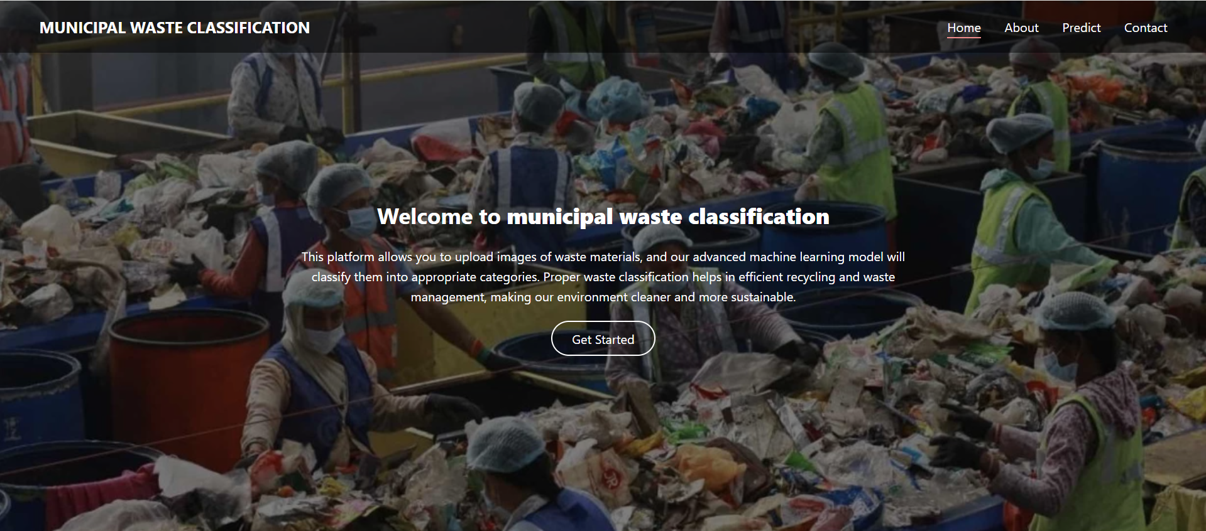

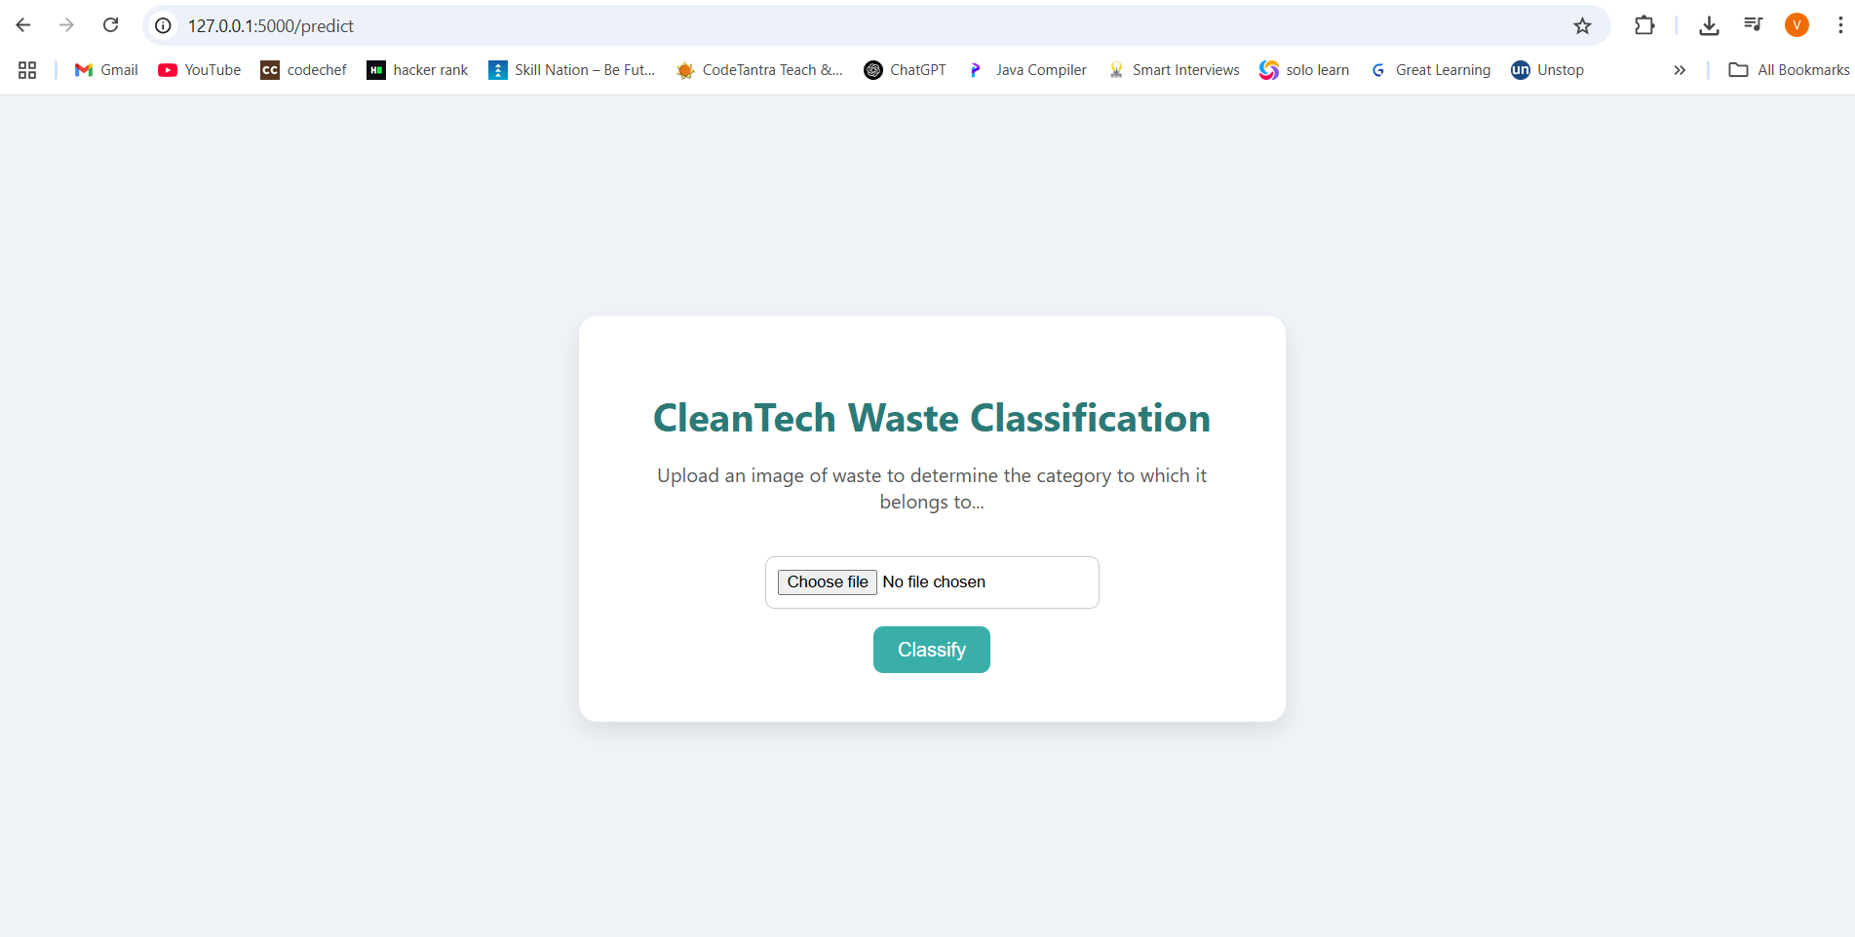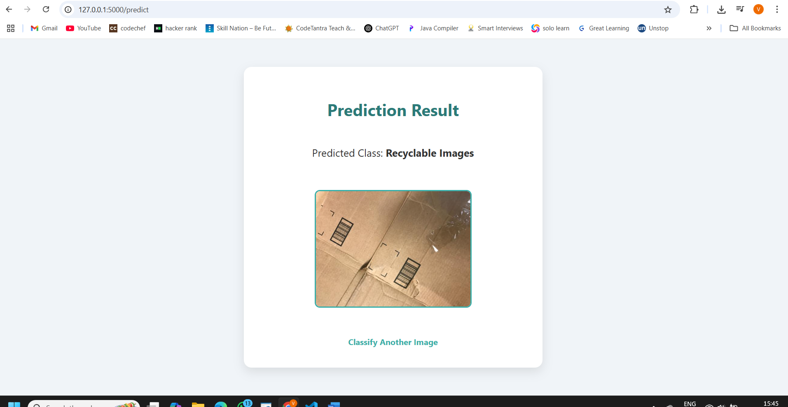 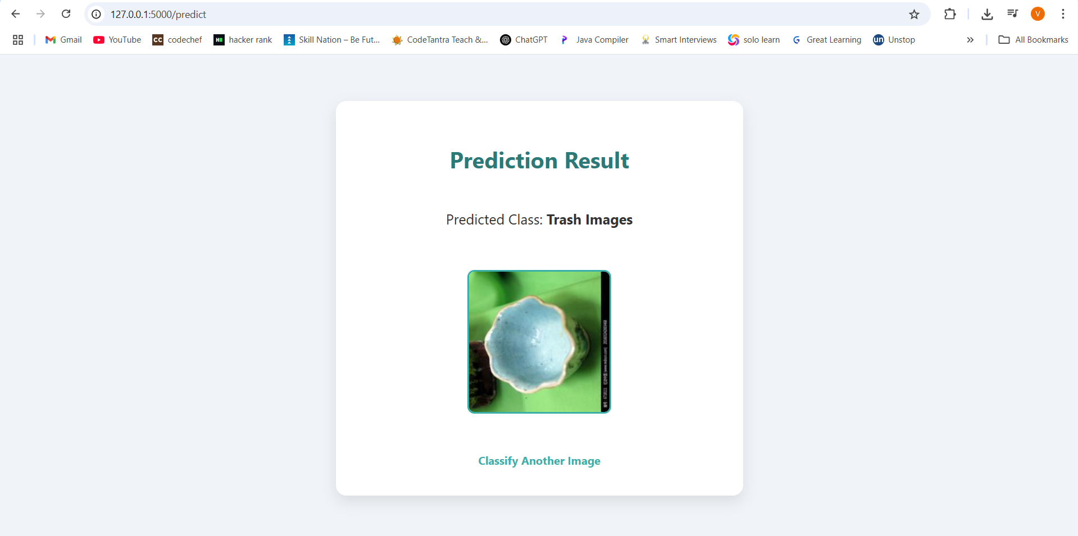 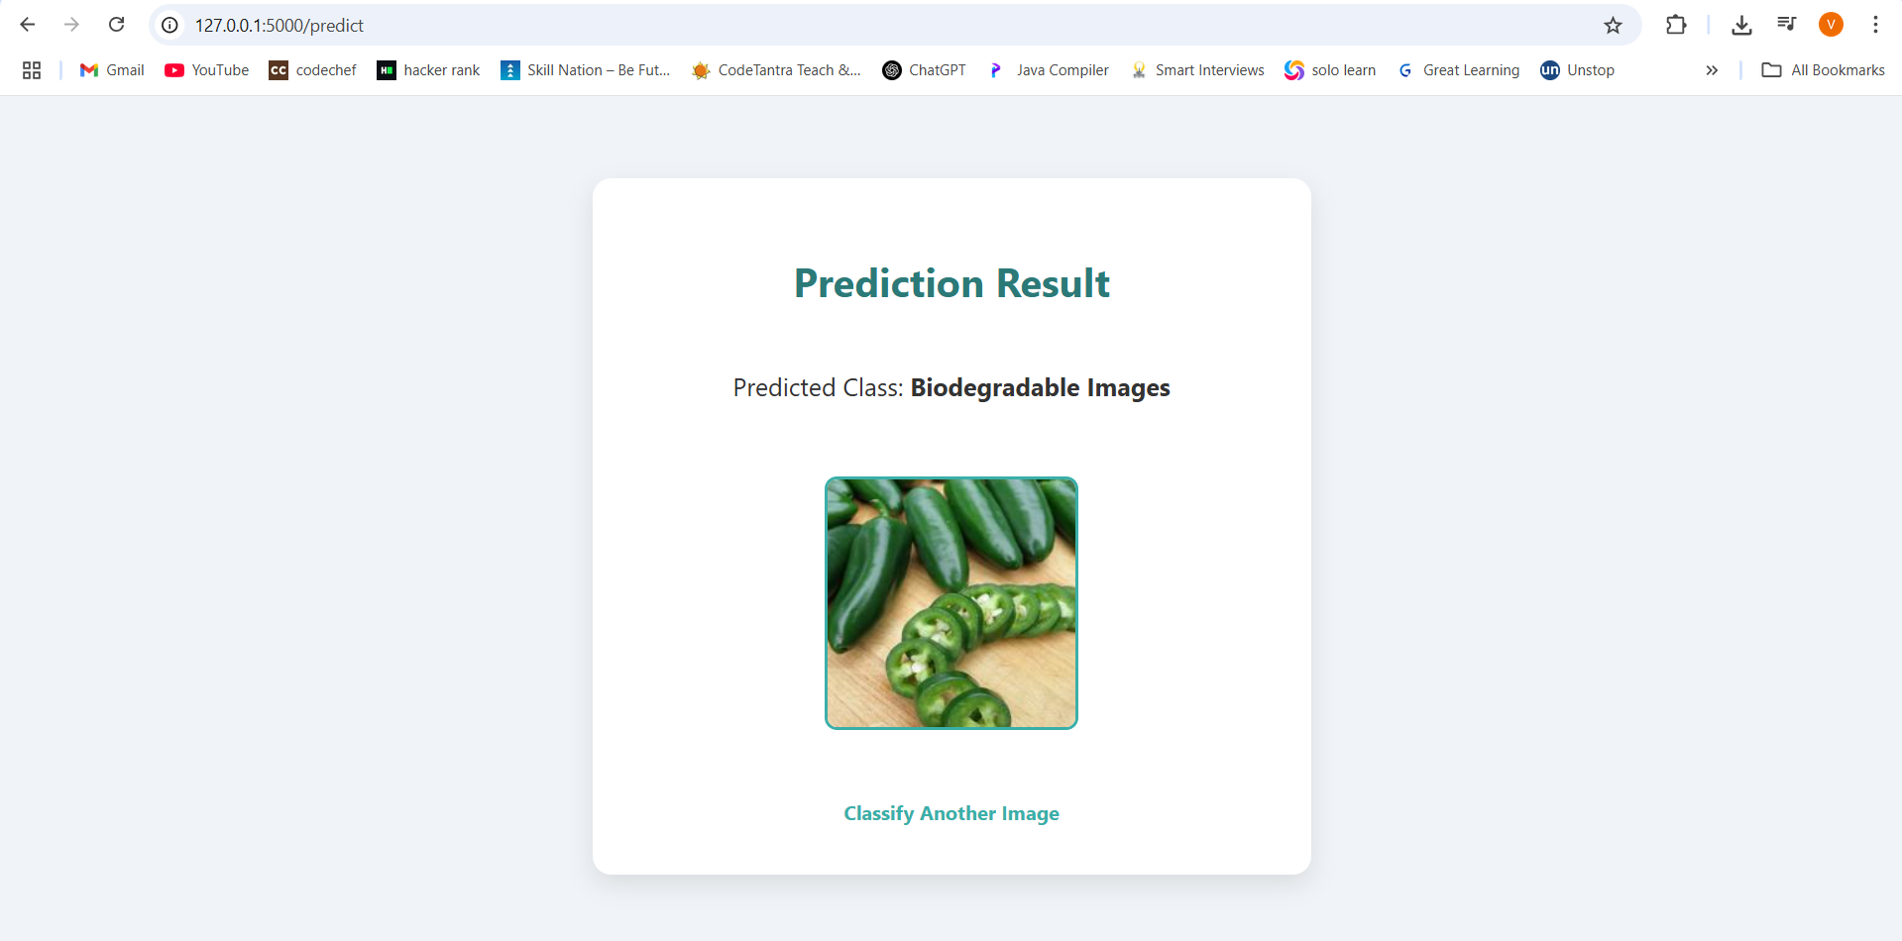

1. **ADVANTAGES & DISADVANTAGES:**

**Advantages: -** Reduces human error - Fast, automated classification - Simple and scalable

**Disadvanatges: -** Dependent on image quality - Needs internet for web-based use

1. **CONCLUSION:**

CleanTech demonstrates the feasibility of using AI and deep learning to automate waste classification. It offers a scalable, low-cost, and eco-friendly solution suitable for urban and industrial deployment.

1. **FUTURE SCOPE:**

Real-time classification in smart bins

Mobile app integration

Deploy via Firebase + Google Cloud Run

Add voice assistant for accessibility

1. **APPENDIX:**

**Source Code: Provided in github  
Dataset:** [**https://www.kaggle.com/datasets/elinachen717/municipal-solid-waste-dataset**](https://www.kaggle.com/datasets/elinachen717/municipal-solid-waste-dataset)

Github:   
Project Demo: